A Better Locking/Logging In Interface for Users with Short Computing Sessions

Jonas Klink Muthukaruppan Annamalai

Department of Computer Science and Engineering
University of Washington,
Seattle, WA 98195-2350, U.S.A.
{jklink, muthu}@cs.washington.edu

Abstract

Today’s logging-in/unlocking interfaces involve entering long, frequently changed text based passwords. Such mechanisms tend to be of an inflexible nature. They only suit normal computing sessions which involve a user logging-in/unlocking the system and using it for a long duration. This logging-in/unlocking interface tends to be inconvenient for professions which require users to frequently leave their workstations and necessitates them to log out or lock it due to the presence of confidential data. As a consequence of this inflexibility, users in such professions avoid logging-out/locking altogether, which could have drastic consequences.

In this paper, we have made an attempt to solve the problem of inconvenient logging-in/unlocking interfaces for users in professions requiring short computing sessions. We chose to study one such profession; that of the nurses, but believe that the results are easily extensible to other professions. We conducted a series of surveys that led us to an interface consisting of a primary fingerprint based login scheme, backed by a secondary PassPoints password system that was enhanced by us for greater usability and security. We conducted a series of heuristic evaluations to design the most suitable interface for these logging in mechanisms.

1. Introduction

Today’s operating systems resort to conventional text based password mechanisms for logging-into/unlocking systems. Textual passwords not only offer a robust solution, but they are cheap to implement as well. No extra piece of hardware is required by the user. Such a methodology of logging in is fine for users who login once and are involved in computing sessions of a long duration. On the contrary, it is cumbersome and inflexible for the class of professions which requires users to log into and out of, or at least lock and unlock their systems very frequently. An example of such a profession is that of the nurses. The reasons for the short computing sessions are a property of the profession. For example, nurses step away from their computers to attend to patients frequently. They cannot leave their computing sessions open due to the confidential nature of the data they handle. The hospital policies necessitate the locking of the systems in their absence.

The inflexible and troublesome nature of passwords arises primarily because (i) they have to be at least of a certain length thus preventing short passwords, (ii) they should be frequently changed (for example once a month), and (iii) they should consist of a variety alphanumeric characters. Keying in and remembering such a password is tedious, especially if the users are not computer savvy. Users in professions that have short computing sessions thus leave their workstations open due to the inconvenience of logging-in/unlocking the system if their absence is only for a short while. This can have dangerous consequences if there is confidential data on the system.

In this paper, we propose a different methodology of logging in for the class of users with short computing sessions. The nurse profession is an example of a profession which requires the users to frequently leave their workstations. Though we conducted our studies with nurses, we expect these ideas to be useful for the class of computer users who have short computing sessions, and are involved with updating confidential data. Nurses use computer systems to log and lookup information about patients. As patients arrive, the nurses look up information to attain details about the patient, such as allergies the patient might have. They also log information about the patient after the doctor decides on the medication and wants to make notes regarding the patient’s visit. Each computing session for a nurse would typically last from five to 15 minutes. The time between computing sessions is around ten minutes. If the logging-in/unlocking of computer systems is cumbersome then most nurses would tend to avoid logging-out/unlocking their systems, and this could have drastic consequences and defeat security that the text based password system was meant to provide. Nurses also share workstations hence the notion of freezing and resuming a computing session is critical to their work. This would allow multiple users to have active sessions at any point of time, without requiring one user to end their session before giving another one access. We have also addressed this problem.

We present a logging-in/unlocking interface that primarily relies on the fingerprint scanning technology. Current fingerprint scanners are not prey to false positives, but might give rise to occasional false negatives. The frequency of occurrence of false negatives is inversely proportional to the cost of the device. It is possible to find expensive fingerprint scanners which give 100% accuracy [1]. These scanners will not provide for cost-effective solutions, hence administrators would have to settle for scanners that do give the occasional false negatives. Repeating the fingerprint scanning process would greatly reduce the possibility of a false negative. But in order to make such an interface complete, and to allow users to login/unlock systems when the fingerprint scanning fails, either due to a hardware failure or due to another factor, we have provided for a backup logging-in/unlocking mechanism. The backup consists of a graphical password scheme that was extended by us for better usability and increased security.

We arrived at the design after extensive surveys of nurses from different medical backgrounds. We implemented multiple backup systems in software and allowed the nurses to try each one before deciding the specifications for an optimal backup system. The rest of the design was presented to the nurses and others using paper mockups in the form of a flip book. We also conducted heuristic evaluations to enable greater usability of the final design of the interface. Section 2 discusses the work environment of the nurses, while Section 3 lists possible solutions. Section 4 justifies the choice for the primary login, and Section 5 discusses the initial design. Section 6 details the final system design, and we present the security aspects of the final system in Section 7. We conclude with future work in Section 8.

2. The Nurses’ Work Environment

We conducted a first survey to get introduced to the environment that the nurses work in. We approached the Hall Health Centre at the University of Washington, Seattle, to see if they were open to us conducting surveys. They studied the set of potential questions we had handed over and approved the survey. Since it is possible for nurses from different departments to have different work environments, we ensured that we got a good sampling of a wide variety of nurses. We visited nurses from the triage section and from the immunization department. For our first survey, we met a total of six nurses, three from each department. The following few paragraphs summarize the information we had obtained as a result of our first survey.

All the nurses were equipped with workstations. The nurses had to share their workstations across the days of the week, while some of them even had to share it within the same day. They were using the Windows XP operating system, with a front-end system called EPIC, which gave them access to the patient’s database. The EPIC system had its own “Secure” button, which when clicked would lock access to the database. Each workstation had a screen placed over the monitor display to ensure that the contents on the screen were not visible for onlookers at a distance.

The nurses logged in once a day in the morning, and logged out in the evening and shutdown the machines. A typical computing session lasts anywhere from five to 15 minutes. During the day, depending on the department and the duration of the absence they used different locking techniques. Nurses in the immunization department, relied heavily on physical security. Patients were not allowed to roam around the workstations in the immunization clinic; hence it was easy to spot an intruder. Access to the workstation was difficult to gain for a patient in the immunization clinic since all the staff would notice such a thing. Thus, when they attend to patients or obtain vaccines, they do not lock their systems. They lock only the EPIC system in case they leave for a long break, like for coffee or lunch. This meant that the nurse’s email clients and other software were still running on the system, open for others. Locking the EPIC system meant that only the database containing the confidential data was locked, while the rest of the user’s session was open. The reason that the nurses in this department didn’t completely lock their systems was because of the cumbersome nature of passwords. The triage nurses, on the other hand, could not afford the same leisure of physical security since the location they worked at was easily accessible for patients. Instead, when they attend to patients or take a very small break, they lock the EPIC interface to the database, while leaving the rest of system open. There are two reasons they don’t do a full system lock. The first reason being that in the triage department, multiple nurses tend to share a workstation, and hence if one of them locks it, it then disallows the others from using the system. When urgency arises, the nurses in such a case proceed to reboot the system. The second reason is that the passwords are cumbersome to enter too frequently. Only on long lunch or coffee breaks do the nurses completely lock their systems.

The nurses had to have passwords that were at least 14 characters long, and were a mixture of alphanumeric characters. The passwords had to be changed once a month. The main complaint from most of the nurses was the fact that they could not type fast, thus entering passwords took a long time. Remembering the passwords and continuously changing them created more problems. They were also required not to write down their passwords.

3. Potential Solutions

To identify what potential solutions exist, we had a brainstorming session between. Apart from that, we also included a question in the first survey which encouraged the nurses to drop all technological constraints, and think of an ideal system. From the brainstorming process and survey results, we then identified that whatever the solution, it should have the following properties:

- It should allow for instantaneous logging in
- It should be easy to understand
- It should be equally secure to the text based password authentication

We then identified, with the help of the nurses, three potential solutions. They were fingerprint scanning, voice recognition and token-based access. We briefly describe each one of these in greater detail in the following subsections.

3.1 Fingerprint Scanning

Fingerprint scanning requires extra hardware support, in the form of a fingerprint scanner. The user is required to place a finger on the scanner and associate the recorded fingerprint with the user’s login. When the user wants to start a computing session, the user would be required to place the same finger on the scanner and it would authenticate based on a fingerprint match.

Prices for such technology ranges from $40 to $150. The quality of the scanner being dependent on the price. A $40 dollar scanner provides an accuracy of around 93%. All the inaccuracies are as a result of false negatives, and no scanner gives a false positive [1].

3.2 Voice Recognition

Voice recognition requires users to train the system with their voice. The training proceeds by requesting the user to read out various paragraphs of text displayed by the system. Once trained, the user only needs to walk up to the system and say something. Based on the voice, it would authenticate the user to start a new computing session, if the patterns matched.

This gives rise to a number of questions. What if the user is simply speaking to someone on the phone and does not want to login or what if someone records the user’s voice and replays it at the login screen? To eliminate these two problems, we thought of an interface that could display random phrases that the user needs to say in order to be logged-in. This phrase could be a simple three or four word sentence. Voice recognition is still a massively studied topic with lots of scope for improvement. It is currently inaccurate and provides false positives as well as false negatives.

3.3 Token-Based Access

A token-based access system requires the user to be carrying around a token, which could be a card, and insert it into a slot or flash it in front of a scanner in order to be authenticated. This is similar to the mechanism used to secure access to buildings by providing authorized users a card which is scanned upon entry. This technique is of course fully accurate and can avoid forgeries with the placement of a smart processor on the card. The main problem though is if the card gets lost or stolen, and the nurses do not realize it and hence do not report it to the administrator. In such a case, anyone with the card can gain access anywhere, which is dangerous.

4. The Final Solution

In order to get a better idea for which solution would work better for our target users, the nurses, we conducted a second survey, where we showed them a video demo of a fingerprint scanner in action and an actual demo of voice recognition software. We ruled out the token-based authentication because it was too dangerous to lose a card. A lost card would not cause a problem if the nurses immediately reported it to the administrator, but it might take some time to realize a stolen or lost card, during which time the system might be compromised.

The nurses were very excited to see the fingerprint based authentication along with its elegance and simplicity. They were not comfortable with the voice recognition software because of its inaccurate nature and also because it might require reattempts before allowing a user to login. This might occasionally require a large amount of time before letting a user login successfully. Multiple retries would hinder a nurse from accessing an account in case of an emergency.

The accuracy and instantaneous nature of the fingerprint scanner led us to make it the choice of authentication. The only concern that was raised was the cost issue. The head nurse was concerned that the fingerprint scanner based solution would be an expensive one. But when we subsequently presented the head nurse with the prices of such scanners, she readily agreed. The cost was looked upon as resulting in greater efficiency.

As previously mentioned, the fingerprint scanning mechanism results in rare false negatives and no false positives. [1] showed that accuracy for expensive scanners was shown to be 100 %, while for less expensive scanners, it was shown to be around 93 %. Hence, by allowing for retries, we could ensure that the number of failures would be low. In the event of a failure, we would require a backup system. Also, since completely software-based logging in mechanisms such as passwords, don’t suffer from wear and tear, while hardware does, we should allow for a backup to enable a user to login even when the underlying hardware breaks. This backup should be completely software based, to ensure proper logging in.

For nurses who share the workstation with other nurses within a day, they are unable to currently lock the system because the other user would not be able to login. Either the administrator or the user who locked it would be required to unlock the system. An elegant solution to this would be to allow for multiple sessions to coexist at the same time. Thus, when a user locks the system, their session is suspended. The next time the same user logs in, the suspended session is resumed. A user with no suspended sessions would be able to start a new session. This functionality is provided by Windows XP, and we just had to make the nurses aware of it in order for them to be able to use the feature.

5. Initial system design

Relying on the extensive feedback received from our subjects during the earlier surveys and tests, we outlined an initial system design, functional as well as design-wise. To briefly recall the main problems we had identified in the current work-setting of the nurses, we were looking for an overall security solution, quickly blocking access to the entire system, while still being swift and easy to access. This ruled out the current solution, for inadequate usability, of textual passwords. Our investigations concerning biometric authentication means seemed promising, but as one of the subjects pointed out, hardware might sometimes be prone to failure, and we needed a backup system to provide overall security and stability comparable to the current systems. The suggestion of a locking system, similar to Windows XP Fast User Switch [2] relying on sessions, was well received, but this current system was still unsatisfactory in many regards.

5.1 The System Takes Shape

Returning to the results from our second user survey, we had the three main parts of our system clear for us; keeping the short, permanent textual username (that users strongly stated they saw no trouble with, even when presented with alternative, suggested solutions), a primary, biometric authentication in the form of fingerprint recognition and finally, a secondary backup system, to provide smooth continuous running of the system, even in cases of hardware failure. In addition to this, we wanted our particular subjects to be presented with a clear and intuitive interface, that appealed to them aesthetically as well as from a usability point of view.

For our third user survey, based on the three parts mentioned above, we therefore constructed an initial screen design to present to the users in our next iteration. The design was represented by two screens, as shown in Figures 1 and 2. Careful consideration went into the design that eventually led up to these two full screens presented. We conducted a brief study of OS specific login/locking screens, and that pointed us towards that the minimalism of Unix/Linux (as the users expressed it) was highly appreciated, in combination with the cheery, slightly futuristic greeting (once again the users’ view) seen in the Macintosh OS (but also somewhat in Windows XP).

As can be seen from the initial screen designs, the colour theme was chosen by us to a hospital-associated white and green, and an effort was made to make the design look simple, but yet readily hold all the information needed by the nurses. An enlarged time-of-day was put in to be available at a glance and basic functionalities as Help and Language setting (for the interface, in case of a more general work setting, where some employees might have English as a second language) were added. Also, easy access to rebooting and shutting down the workstation was added separately, all in line with feedback we got on extra clicks and choices not being wanted. The second screen, the fingerprint scanning stage, was presented with minimal, but (what we hoped) clear instructions, as well as a visual instruction. The texts were made general on purpose, and are of course subject to customization depending on specific scan hardware, and the feedback it provides for the user.
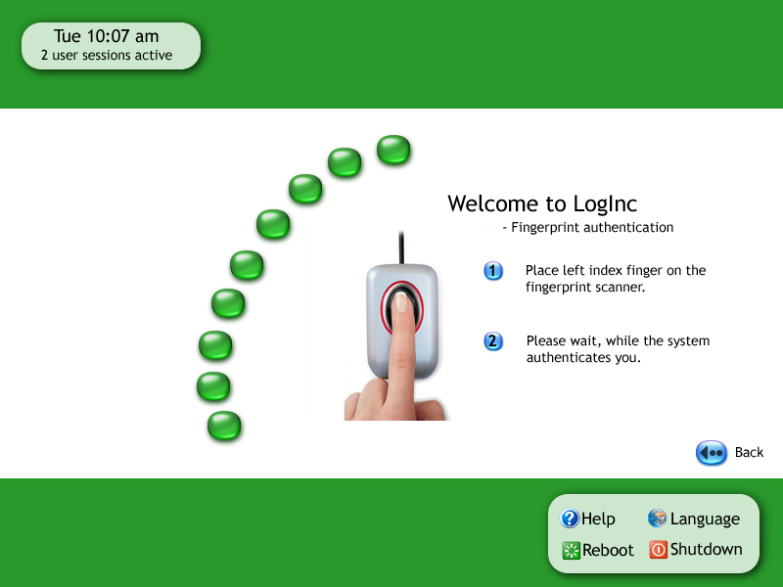
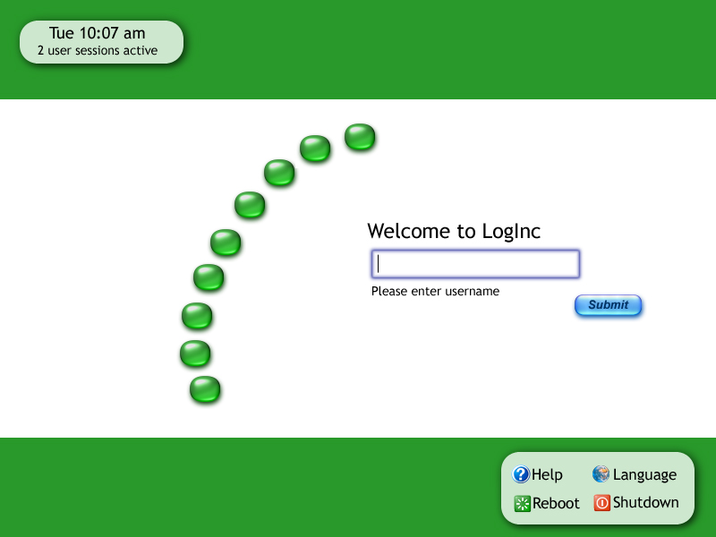
Figure 1. 1st iteration interface
Figure 2. 1st iteration fingerprint scan

5.2 Graphical Passwords as the Backup System

Before presenting our third user survey, we needed some theoretical background on the systems we suggested as backup in case of the biometric system malfunctioning. In addition to the users’ requests on swiftness and easy access, this system needed to rely only on software (to prevent further exposure to hardware failure). Also, since the rates of failure and false negatives with fingerprint scanners are low [1], the means of authentication needed to be easy to remember, even when used seldom over an extended period of time. To meet this very important constraint, we turned our attention to a collection of authentication methods referred to as graphical passwords [3]. However, instead of having to memorize and enter a long string of random-like alphanumeric characters (the system in current use with the nurses), a sequence of images or image parts must be selected and retained. Experimental results suggest that human visual memory is well suited to such visual and cognitive tasks [4, 5]. Moreover, an image or image sequence that has some meaning to the individual user (e.g., childhood friends, favourite sport, or something similar) can be used. If forgotten, the sequence may be reconstructed from the inherent visual cues. We present two systems of our choice; PassPoints [6] and a version of the Picture Password modified by us, originally introduced in the mobile device setting by [7].

5.2.1 PassPoints

Referring to the security and usability problems associated with alphanumeric passwords as “the password problem” [11] (which basically treats the trade-offs between security and ease of authentication), the problem we are facing here is even slightly more complex. Due to the low failure rate of fingerprint scanners [1], the authentication means also needs to be memorable for infrequent use over an extended period of time.

[6] presents with their papers on PassPoints an interesting means of meeting these requirements. Memory of passwords and efficiency of their input are two key human criteria. Depending on the graphical password system, at input time users will be presented with either a recognition task or a cued recall task. In a graphical password system based on recognition, the user has to be able only to recognize previously seen images, making a choice of whether the image is included in the authentication or not. Recognition is an easier memory task than pure, unaided recall [8]. The PassPoints system uses an intermediary form of recollection between pure recall and recognition, called cued recall. Scanning an image to find previously chosen locations in it is cued recall because viewing the image reminds, or cues, users about their click areas. Users need to be informed upon customization time on click sensitivity settings for the specific system, and choose their password points in a given order. Security depends on number of clicks and the constraint on ordering being important, and will be discussed further in our Comparing security section below. For a full discussion on the design of PassPoints, see papers under [3].

5.2.2 Picture Password
Another approach, as briefly mentioned above, is a system based on recognition of images. As far as we knew, related work of statistical significance is meagre on this topic, and we therefore wanted to present our subjects with the options of making their own opinion of the two major approaches to graphical passwords. The Picture Password [7] is an approach based on recognition, rather than PassPoints’ recall. The system is an interesting one, with many inherent advantages and limitations to explore still. Since being originally developed for mobile devices with small screens, and having a higher physical security than that found in the work environment we are developing for, the system still suffers from being sensitive to “over the shoulder”-attacks (for a brief discussion on this type of attacks, see [9]).

The basic idea of the Picture Password (existing in several variations) is that the users choose a number of pictures that constitutes their password sequence. Upon an authentication attempt the user is presented with these pictures in a grid, together with a given number of other (possibly similar) images, not included in the correct, chosen password sequence. The position of the correct images can be randomized, and the user may or may not be constrained to enter them in order. Also, to facilitate recognition, a theme of the user’s taste might be chosen, or a full image might be split into a grid of (independently meaningless) sub-images. For examples of this, and a further discussion of the design and maintenance of the Picture Password, see [7]. Apart from the “over the shoulder”-attacks, the system has issues with image selection and generation, as will be discussed further shortly.

5.3 Feedback on Initial Design: Third user survey

Returning to our subjects at Hall Health, we hoped for feedback on several parts of the system design (see Appendix A for full survey questionnaire for the third iteration user study). We wanted to probe for an overall impression of the screen designs, as well as if any details were unclear in their use, design or placement. An important issue at this stage was also to get the overall layout and coloring aesthetically pleasing, as we started to move towards a system that might soon come in possible use. Secondly, we had also implemented a simple authentication system, comparing the use of textual passwords with that of PassPoints and the Picture Password.

5.3.1 UI screen designs feedback

When questioned regarding the overall impression of the screen designs (as presented in Figure 1 and Figure 2 above; used throughout this entire feedback discussion for any design references), as well as any unclear details, users can be said to have received it most positively. From the three nurses we used for this round of testing, we got comments including adjectives like cheery, nice and clear, and simple looking. Discussing the screen designs briefly with our peers before the study, we decided to investigate concerns regarding the green bullets being mistaken for action buttons, as well as users needing more clear feedback, such as “step 1 of 3”. These concerns proved to be unfounded, since all subjects answered negatively to them being any problem.

Subjects furthermore liked the layout, size and fonts of texts, and that it told them how many active sessions there were. The colors were very good, and one of the subjects associated the color green with “Go”, which was very positive for her. The purpose of the larger day-of-time was said to be clear (as well as appreciated), and found to be readable from a distance, even with subjects with slightly limited eye sight. For the fingerprint scanning screen, instructions were said to be understandable and succinct.

Suggestions for small improvements that came up was that the button text “Submit” (on the username screen) would be more intuitive as “Enter”, and that LEFT in the text “left index finger” (on the fingerprint screen) should be in caps or bold, to be even more visible. Instructions to keep finger on fingerprint scanner, instead of “please wait…” were also requested. Moving on to the next iteration, these changes were incorporated.

5.3.2 Graphical password system evaluation

For this part of the study, we implemented three demo applications, allowing the users to enter a username, and then further authenticate themselves by either a textual password, with a PassPoints-based system and a Picture Password-based system, respectively. We had set the number of points to click and the number of pictures to choose to four each, and chosen a (by the head nurse suggested) theme of superheroes for all the pictures (for screenshots of our demos, see Figures 3-4 below).
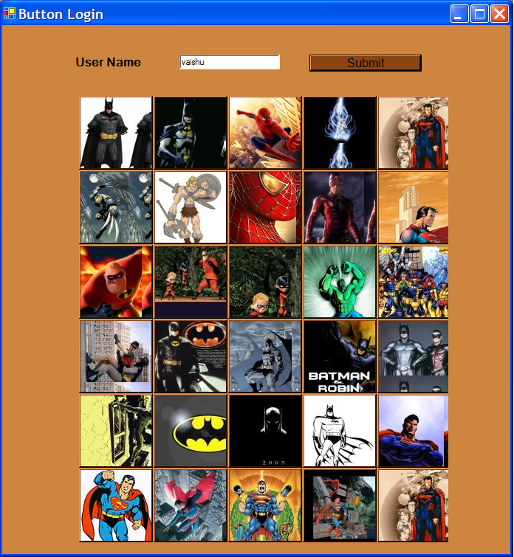
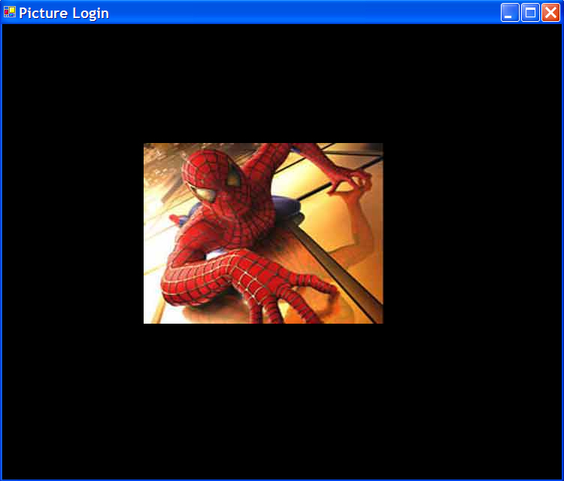
Figure 3. Picture Password demo
Figure 4. PassPoints demo
Feedback on both suggested graphical systems was very positive, and users all agreed on the benefits over the textual password being clear. For PassPoints users liked the fact that there was only one picture to choose, not an entire theme. They felt that the process of selecting pictures for the entire theme (or at least the ones used in the password sequence) in the Picture Password might be very time-consuming. When comparing the two, our subjects felt that the system based on multiple pictures might damage from the randomness, in that they might resort to choosing pictures in a pattern, e.g. top-to-bottom, which would compromise security (more on this in Comparing security section).

Given these arguments, we decided to go with the PassPoints-system as a backup, making slight alterations and additions to it (as will be discussed below). Users seemed overall to be comfortable with both systems, and when shown a password sequence only once, they could after a pause for questions still correctly enter the correct points and pictures. Ideally, we would of course like to extend this study to a more reliable one, spanning over a significant period of time, and potentially establishing the memory advantages of the graphical passwords compared to the textual. The results presented in [6] are compelling, but still not enough to fully confirm a statistically significant advantage.

6. Full system design

For the next iteration, we planned a full design of a system mock-up, in accordance to an established system map. This design was to be evaluated in the form of a flipbook, through a heuristic evaluation.

6.1 System map and full screen design

The design of the full system was started by establishing a system map, covering all transfers between screens and occurrence of popups. This map can be seen in Figure 5 below.
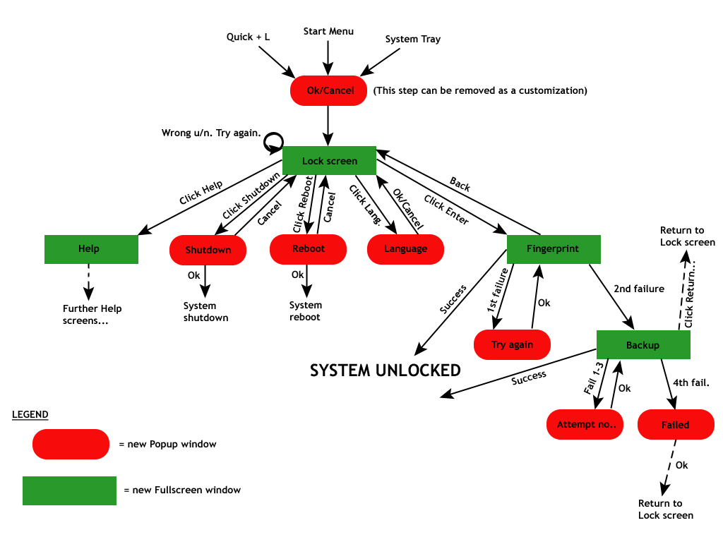
Figure 5. System map.

Although possibly hard to pull every detail from in this small format, it still conveys most of the functionality we had in mind during the design. As said, all green boxes symbolize a screen change, whereas a red symbolizes a popup. For sake of brevity, the full Help path is left out, and these screens were also not designed for the flipbook. Otherwise, the three full screens (Lock/Username screen, Fingerprint scan screen and Backup authentication screen) are all fully designed, with the addition of all possible popups.

It should also be noted that we plan on making the Lock screen reachable via the Windows Start Menu, the Windows System Tray and also a quick command, to support all levels of user proficiency. All choices are provided with a Cancel ability (which in the case of reaching the Lock screen can be removed as a customization option), although we tried to be as restrictive as possible with this, to minimize the number of user clicks.

Presented in Figure 6, the Graphical Password screen appears. The two other fullscreens are generally unchanged since the initial design, with the exception of the user requested changes of “Submit” to “Enter”, and the caps-version of LEFT in “…left index finger”-phrase. Additionally, for the sake of consistency, only the screen action buttons are kept in blue (as can be seen on the change of color of the bullets on the fingerprint scan screen). The PassPoints-based system has been extended by us to contain usage instructions and a Progress feedback.
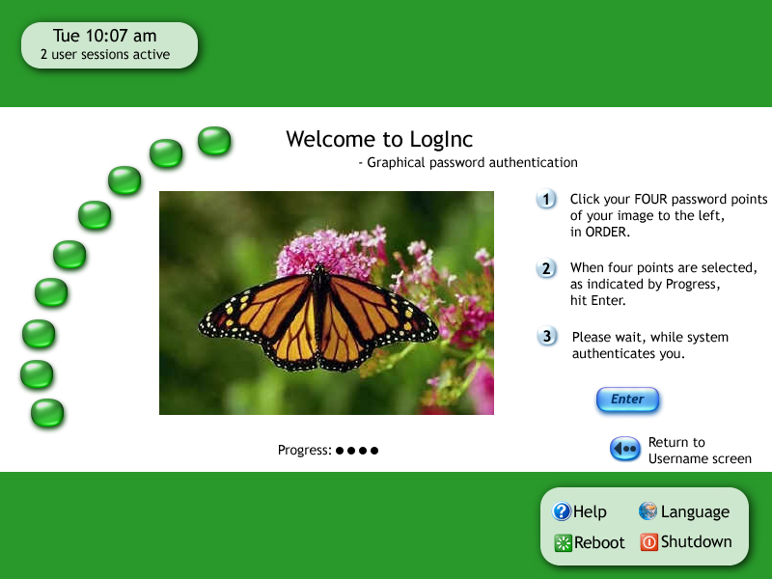

Figure 6. Graphical password screen

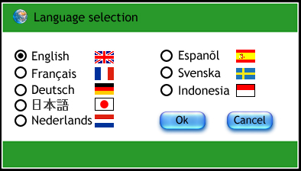
As mentioned, in addition to the full screen designs, we made a full implementation of all popup windows accessible from the interface, as well as our own mouseover (to keep our look-and-feel consistent). The main classes of popups in our interface are the Language popup, the Reboot and Shutdown popups and all error notification popups. Unfortunately, this report does not have the space to fully convey and display the full design in all its aspects (see Appendix B for full screenshots).
Figure 7. Language popup

As an extension to the services needed by our users at Hall Health, we wanted to provide the UI with several language alternatives. This idea was approved of in our third user survey, where subjects found it a good idea for further deployment. The popup is visible in Figure 7, and can be seen to consist of a simple radio-button design of our own.

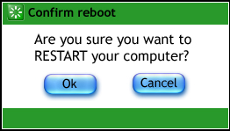
These two popups are slight variations on the same design, where the words and icon being the only difference. As can be understood from Figure 8, they provide an extra security step against accidentally hitting either of the options.
Figure 8. Reboot popup

6.2 Heuristic evaluation

As a means to get quick and useful feedback on our full screen design, we presented two other designers with the full flipbook of our design, and asked them to evaluate it in accordance with Jakob Nielsen’s list of Ten Usability Heuristics [10]. They were presented with three tasks, to ensure they were exposed to as much of the system functionality as possible:

- Rebooting the computer
- Setting the Lock/Username screens language to Swedish.
- Entering a given username, using fingerprint scan (which will simulate an authentication failure) and then authenticate themselves with the backup system.

We will here present a condensed form of the most important positive and negative feedback we received.

Overall, the system was said to have a good choice of language and aesthetics, while providing good feedback through the popups, without being annoying. One of the designers also gave a big plus to the ease of which one can authenticate oneself in this system, as well as providing a quick, simple and innovative backup system.

In the case of user control and freedom and error prevention, both designers requested a clear/undo button for the graphical password screen. Also, having reboot/shutdown available without authentication protection is an issue our interface shares with several other OS login screens. Suggestions were made for improving the security, by removing the constraint of a fixed number of pass points.

As aesthetic and minimalist design was considered a feature of our UI, one of the designers still remarked upon the instructions for the graphical password still needing some work. The mass of text made the screen look unnecessarily cluttered, while not providing quite enough explanation on why the backup system actually kicked in.

Finally, for the visibility of system status, we had an interesting dialogue concerning the possible need for a timeout on the two authentication screens. If the user’s unlocking procedure is by some reason aborted in midway, the system should recognize this after a while and return to the Username screen. The same goes for fingerprint scan hardware failure, where the user should be presented with the backup graphical password system.

6.3 Interesting Issues

For the feedback received from the heuristic evaluation, there are some interesting issues to deal with in upcoming iterations (not possible to do in this short course project). We will present our test subjects, the nurses, with our current system solution as thanks for all the fantastic feedback we have gotten. It would in an implementation be interesting to compare our locking mechanism to that of Windows XP, and investigate effort and time put into authentication, using the two different systems.

For the next iteration, we see two main interesting points to pursue for our UI and security system. Firstly, we need some kind of timeout mechanism, that will counter the security weakness of users having to leave their workstation in the middle of an authentication session (e.g. during fingerprint scan or graphical password entering). This timeout will also have to deal with what to do if the fingerprint scan hardware is not responding. As a visionary solution to this, one could imagine introducing a short timeout for the fingerprint scanning, which would take the user to the graphical password backup system. Another timeout here would return the user to the Lock/Username screen. Interesting issues with this approach is how to provide feedback for the users on what is going on, plus how to properly set the timeout interval.

Secondly, another in the OS world seemingly unsolved issue is how to properly deal with the language setting and re-setting of the UI. Today, most OS that provides a language setting option do so within separate sessions, while keeping the login/locking interface in English. We do not see this as a fully satisfying solution, since it does not cater to the people who cannot speak English at all. Presented with a shared workstation, users might have issues with finding and correctly using the language setting option. Also, if you (as we do) actually do provide different language versions of the whole interface; then what if users leave it in a (to the next user) not understandable language? Should the interface default back to English after a timeout? Should the Language setting button be kept in several languages at all times, or should the mouseover offer that option? Can one find a universally acceptable icon, which will be clear to symbolize language setting? The answers to these questions are not clear, and this strikes us as another interesting line of thought to pursue.

7. Security

A system is only as secure as its weakest link. In our case, the fingerprint scanner, due to the absence of false positives, can be considered to be more secure than the backup system. The only problem with the fingerprint scanner is that if a person obtains an imprint of a person’s fingerprint, then they could gain access to the system. This can be defeated to a certain extent by requiring a person to place different fingers on the scanner at different times.

As mentioned before, the PassPoints system allows users to choose a picture of their choice and choose different clicks on it. When the user wishes to login, the picture is thrown up, and it provides some context for the users to remember their clicks. Numerous kinds of pictures can be chosen by users. Figure 9 shows a class picture. Users could use such a picture that was taken in a high school grade and the clicks could be on faces of people whom they considered best friends. Conversely, it could also represent people most hated. Here users would only be required to remember that they chose most liked/disliked people in that order or in reverse order and they would be able to reconstruct their passwords. Figure 10 shows a different kind of a picture where we have one entity in focus. Here, users could chose to click based on points that are most appealing to them or could decide to click based on favorite colors or shapes.

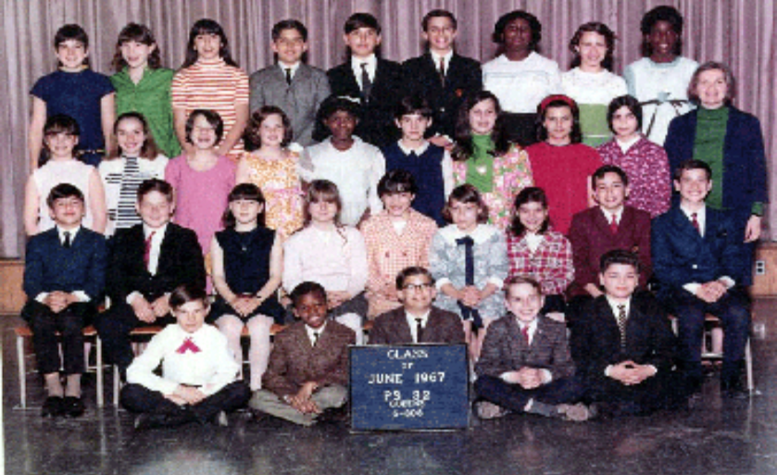

Figure 9: A classroom picture which allows users to click on faces based on relationships. For example, friends.


Figure 10: A butterfly in focus in the picture surrounded by interesting flowers would allow users to click passwords bases on interesting colors and shapes.

The PassPoints system passwords are more secure than text based passwords as far as brute force attacks are considered. A text password of length N would have a total number of possibilities denoted by 50^{N}, assuming a total 50 of characters that are allowed for the choice of a password. For a picture based password, if the picture is 800 X 800 pixels, then the total number of pixels would be 640000 pixels. If each click denoted a 10 X 10 pixel box, then we would have 6400 possibilities. If N clicks were made then the number of total possibilities would be 6400^{N}, which is enormous and much greater than 50^{N}. By letting users pick the value for N, and ensuring that N doesn’t fall below a threshold value (possibly 4), the PassPoints system’s security can be shown to be superior to that of the text based password system, as far as brute force attacks are concerned. The main problem with this system though is that it is vulnerable to over-the-shoulder attacks. But in settings like hospitals, there are special screens around the display to prevent others from peeping into the screen. Hence, this would prevent the option of over-the-shoulders attack.

8. Conclusion and Future Work

The conventional text-based password authentication mechanism does not suit users who have short computing sessions. Text-based passwords are tedious and cumbersome due to a number of reasons. They are required to consist of alphanumeric characters and are also required to be of at least a minimum length (typically 15 characters) which makes it difficult to remember these passwords. Users are also required to frequently change passwords, and this does not make it any easier. We proposed a solution in this paper for exactly the class of users with short computing sessions. After extensive surveys and heuristic evaluations, we came to a design consisting of a primary fingerprint based login, backed up by the PassPoints login. We ensured that the resulting system allowed for instantaneous logging in with an easy to use interface. The proposed system was shown to provide good security.

Future work would be to build upon the backup logging in mechanism. When we presented users with the PassPoints and Picture Password login mechanisms, users chose the PassPoints solution. They expressed their concerns with the Picture Password logging in, such as it being more vulnerable to over-the-shoulder attacks, and it being more difficult to remember pictures in a certain sequence as opposed to remembering points on the picture in a certain sequence. But users did provide lots of feedback which could be pondered upon to see if any drastic changes to the Picture Password login system can make it more usable. Current work is stalled primarily due to technological limitations. For example, there are other ideas we had, such as taking a picture of a user as the user sits in front of the system and authenticating based on a facial match. Current computer vision techniques are not sufficiently advanced to perform this task with complete guarantees.

References

[1] Performance Tests: Fingerprint Biometrics. http://www.pcmag.com/article2/0,1759,96260,00.asp.
[2] Windows Fast User Switch. http://www.microsoft.com/resources/documentation/windows/xp/all/ proddocs/en-us/fast_user_switching.mspx
[3] The Graphical Passwords Project. http://clam.rutgers.edu/~birget/grPssw/
[4] A. Goldstein and J. Chance. Visual Cognition for Complex Configurations. In Perception and Psychophysics, 9, pp. 237-241, 1971.
[5] D. Melcher. The persistence of visual memory for scenes. Nature, 412(6845), p. 401, July 2001.
[6] S. Wiedenbeck, J. Waters, J-C Birget, A. Brodskiy, N. Memon. Authentication Using Graphical Passwords: Basic Results. To appear in Human-Computer Interaction International (HCII 2005), Las Vegas, July 25-27, 2005.
[7] W. Jansen, S. Gavrila, V. Korolev, R. Ayers, R. Swanstrom. Picture Password: A Visual Login Technique for Mobile Devices. In National Institute of Standards and Technology, Interagency Reports, 7030, July 2003.
[8] D. A. Norman. The Design of Everyday Things. Basic Books, New York, 1988.
[9] B. Hoanca, K. Mock. Screen oriented technique for reducing the incidence of shoulder surfing. The 2005 International Conference on Security and Management. SAM 05, June 20-23, 2005, Las Vegas, NV.
[10] J. Nielsen: Ten Usability Heuristics. http://www.useit.com/papers/heuristic/heuristic_list.html
[11] S. Wiedenbeck, J. Waters, J.C. Birget, A. Brodskiy, N. Memon, PassPoints: Design and longitudinal evaluation of a graphical password system. To appear in International J .of Human Computer Studies (Special Issue on HCI Research in Privacy and Security).

APPENDIX A

1. First Survey

QUESTIONS TO UNDERSTAND THE WORK MODEL
--------------------------------------
Tell me about your job

Interviewed 5 nurses, 2 were part of the triage team; taking phone calls (consulting) and assisting doctor, meeting patients. Helps out in case of emergencies in other departments.

Last three was immunization nurses; sees patients (including travellers) for vaccines and keeps records for done work.

What kind of a system are you using?
-Probe for details on nature of use
-Can we see the system?

Uses Epic software, both departments did. They are using Windows as underlying OS. Most important feature of system is the “Secure” button.

How many people share your workstation?

In immunization department, computers are shared across days, but not during days.

In some cases, computers had a primary first user, and in others, they were shared by up to 3 people.

When do you lock/unlock your system?

IMM department rely on physical security heavily. Use secure button for longer breaks, but otherwise does not lock the system, when patients are to be fetched.

Triage nurses: one (the one with the more permanent work station) uses ctrl+alt+del to lock the comp., while others should only use secure button, for no to block the system entirely for other sharing nurses. When locking with ctrl+alt+del, the system has to be opened by the same person or an administrator. Support might be hard to reach for such menial tasks, and they then often reboot the computer as a solution instead, potentially loosing work that way.

In the IMM department, the problem with reaching support was considered less, possibly since they could get (password) support over the phone, or had more serious, prioritized problems.

When do you login to your system?

All personnel are logging into Windows, e-mail software, Epic and so on, every morning. Systems are shut down during the night.

How much time do you spend per session (maybe get details on what they
do)?

Triage nurses spend 5-15 minutes per session, secure systems when running off, getting information, and patient is still in there.

IMM nurses pull up information in beforehand, and then give the vaccination, ending by updating records when patients have left.

If you don’t lock (logout) of your system, what is the reason for that?
-Physical security
-Trustworthiness of people around
-Not very sensitive data

Immediate emergencies. (Triage)

Physical security (IMM).

General hospital policy states that screens should be locked whenever left, and also specifies password security and so on.

QUESTIONS TO UNDERSTAND THE PROBLEMS WITH CURRENT INTERFACE
-----------------------------------------------------------

What do like with the current interface?

Graphical parts good, no font problems.
Get infinite attempts for password.

What is troublesome or annoying with the current interface?

Passwords are too long.
Frequent changes (30 days), makes them hard to remember the first days at least.
Have to be combination of numbers/letters.
Case-sensitive.
Cannot use previous passwords.
How frequently do you change your passwords?

When prompted, at least once a month, they have to change the password (see constraints above).
Prompt appears 14 days before expiration. This was disliked by many of the users, and they were bugged by the added time for a login.
Reminder came too early, they thought.

QUESTIONS TO UNDERSTAND POTENTIAL SOLUTIONS
-------------------------------------------

Dropping all restrictions, what do you think is the simplest, most
effective way to login to the system? (evaluate existing system question)
-Suggest alternatives like fingerprinting, voice recognition

Fingerprint recognition.
Voice recognition.
Wireless token.

Is there anything in your work environment that would limit the ways in
which you use the system?

IMM people do not feel constrained.
One of the triage nurses said she might at rare occasions have to look up information while being in the process of dressing a wound.
System was used in broad way.

THINGS WE HAVE TO OBSERVE
-------------------------

We have to observe if there are disabled people working

No disabled people employed, due to you have to be agile with patients, and mentally disabled made it difficult for social interaction. Disabled people are mostly working at the reception, if ever.

Who uses the system?

Had good sample of the nurses. (asked the head nurse on how she selected these)

--------------------------------------------------------------------------

OUR OWN REFLECTIONS
The nurses are not quite what you would call tech-savvy, and are having issues typing the passwords and keeping security often only by physical restrictions in the environment. Responded positively to every other technique for authentication, either suggested by themselves or by us, and seemed more intrigued by the “coolness”-factor of it, than actually thinking much on the pros/cons. We will therefore conduct an extra, small survey to determine biometrics usefulness in this work setting.

2. Second Survey

QUESTIONS REGARDING THE SYSTEM DESIGN IN GENERAL (describe it)
--------------------------------------------------------------

What strikes you as positive about this design suggestion?

The nurses thought that our suggested system with sessions should work for their setting. They thought this was a very good approach, and was happy about it. Comments that came up were that it would take away the need to restart a computer locked with a full lock, and it would also protect the open work and data.

What strikes you as negative/missing about this design suggestion?

They could not see any problems with the solution, as described on a high level.

QUESTIONS REGARDING USERNAME AND INTERFACE
-------------------------------------------

What would your reaction be to having an image to select instead of typing your username?

The users in general felt that the username was not the problem with the current interface and authentication, since it was permanent and easy to remember, short. Only one user was indifferent between the username as it is today, and a single picture for identification.

Multiple images, in a predefined series?

This was perceived as difficult to remember, and much harder than the current username option.

What would you think about a signature/gesture pattern username?

As multiple pictures were considered too advanced already, this was perceived as even more of a hassle.

QUESTIONS REGARDING THE BIOMETRICS (VOICE RECOGNITION)
-----------------------------------------------------------

Would this system seem usable to you, in your work setting?

The voice recognition system had some difficulties that might have biased the result compared to the fingerprint scanning. This is probably due to the fact that the fingerprint was demonstrated by a pre-recorded, positive demo, while the voice recognition system was demonstrated live. Most positive reactions included that it seemed okay, good at best, and that it was probably a cheaper solution than the fingerprint scanner. Users liked the idea of having easy, changing phrases as “challenges”.

Could you think of anything negative/hindering?

Users were concerned about when having some voice deficiency, like a cold, and background noise. One user said she would be feeling strange talking to her computer. Training sessions could also be a problem.

QUESTIONS REGARDING THE BIOMETRICS (FINGERPRINT SCAN)
-----------------------------------------------------------

Would this system seem usable to you, in your work setting?

This was perceived by all of the users as the winner between it and the voice solution. It was permanent, easy to use (even when occupied with a patient) and with you at all times. No need to hide anything from anyone, as is even the issue of the voice (recording).

Could you think of anything negative/hindering?

Cost was considered the biggest factor here, especially by the management part of the staff. Issues about what would happen if the scanner became smudged/dirty came up. A backup might be needed in case the system fails. Taking off gloves is off course an issue, but since that is needed and put down as a policy anyway, that was not really a negative point (gloves are not used that often by these nurses).

--------------------------------------------------------------------------

OUR OWN REFLECTIONS
We saw a clear trend towards the nurses preferring the fingerprint scanner, with the only issues of the cost and a backup system. We will need to see what the cheapest scanner with good performance cost, and use a backup system to cover any loss in performance (introduction of false negatives, no false positives allowed). For backup system, recognition-based graphical passwords will be investigated, since they are not dependent on a sequence of pictures, which the nurses felt was difficult to remember. For the username, a text-based (not shown as a selection, but just with an empty field to enter it) one will be used initially and evaluated. Interface design will include intuitive fingerprint scan instructions, restart and language options.

3. Third Survey

QUESTIONS REGARDING THE USER INTERFACE SCREEN DESIGN (show it)
--------------------------------------------------------------

What is your overall impression?

Comments were very positive on the interface, and included adjectives like cheery, nice and clear, and simple looking. Worries regarding that the bullets would be confused for buttons was not at all confirmed by the nurses, and they also felt that feedback on where in the authentication process the users were, was not needed. Two or even possibly three login attempts for the fingerprint scanning would be fine.

Subjects liked the layout, size and fonts of texts, and that it told you how many active sessions there were. The colors were very good, and one of the subjects associated the color green with “Go”, which was very positive for her. That the cursor started in the username window automatically was perfect.

Suggestions for small improvements that came up was that the button text “Submit” should be clearer as “Enter”, and that LEFT in the text “left index finger” should be in caps/bold. Instructions to keep finger on scanner, instead of “please wait…” was also wanted.

In short, the interface was said to seem user-friendly, and that almost nothing needed to be changed.

Is there anything (usage/purpose) unclear?

Nothing seemed to be confusing, apart from small comments included in paragraphs above.

Is it aesthetically pleasing?

The subjects liked the color combination, and found the UI very pleasing. Instructions were considered (after proposed small adjustments) to be clear and succinct. There was no need to indicate steps. They liked the idea of being able to see the clock at a glance, and thought the current settings allowed that perfectly, even for people with slightly lesser eye-sight.

QUESTIONS REGARDING THE GRAPHICAL PASSWORD MECHANISMS (demo)
--------------------------------------------------------------

What are your first impressions of the picture login?

Users liked this graphical password. Only one picture to choose, not an entire theme, was great. Thought it would be easy to remember, and liked that there was no need for randomness in the picture presentation. Users did well in remembering the password after having been showed it only once and not even selected it themselves. The small non-sensitivity of where you clicked was good, but should for security of course not be made too big.

What are your first impressions of the button login?

Users thought they would remember which pictures were in their password, but they thought order might be difficult to remember, especially if shifted around. If relative order did not change (e.g. 1 was always above 2), it would make it easier. One subject thought many would select from top-to-bottom, so shifting position only within one row, possibly up to in a triple of rows, would improve ease of use.

Which would you prefer?

Subjects agree that there is an issue with remembering a password over time, and thought the graphical solution would improve upon this. There was a divide between users liking either system better, but arguments for the picture password seemed to be the winning ones. Benefits of this were that it would be less of a hassle to change picture(s), but the liked also the theme idea of the button password.

--------------------------------------------------------------------------

OUR OWN REFLECTIONS

Users seemed to like both graphical passwords, and the button-based one would hold a lot of benefits, but needs more research on it we think. Especially, we think it is more sensitive to over-the-shoulder attack. Both systems need a visual feedback on how far in the clicking process the user is.

The smaller fixes on the UI will be done, and we will proceed by completing a flipbook and an improved demo for the graphical password. These will be presented to a heuristic evaluation and a final user study, before completion of this course project.
APPENDIX B 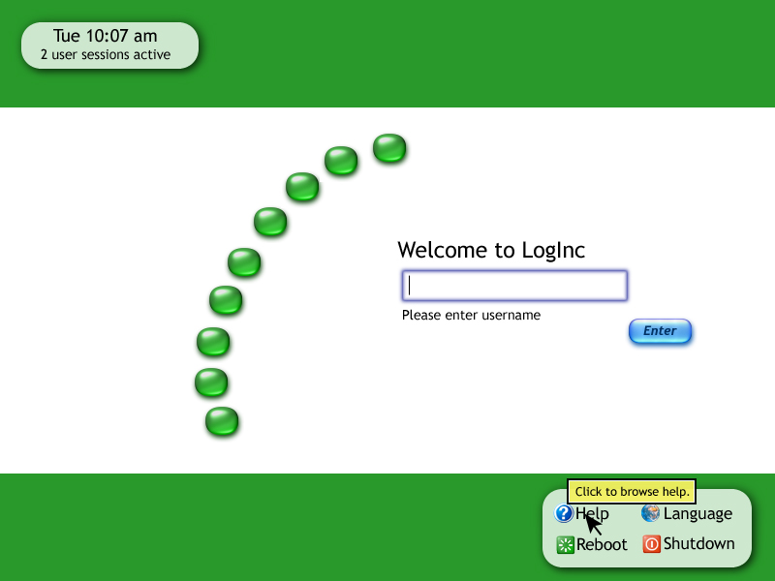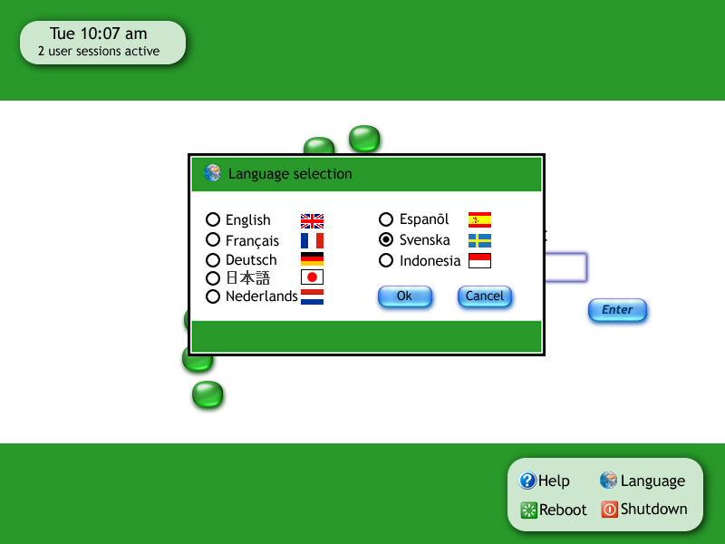
Figure B.1 Initial Screen
Figure B.2 Language Selection
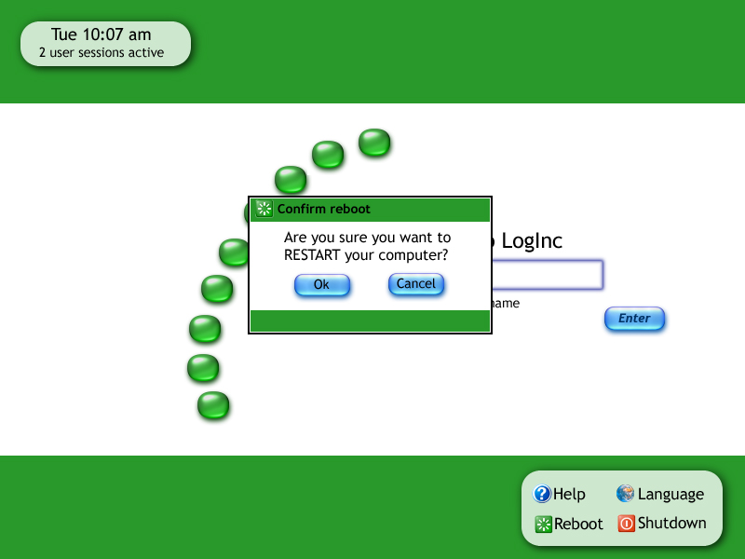
Figure B.3 Restart Screen
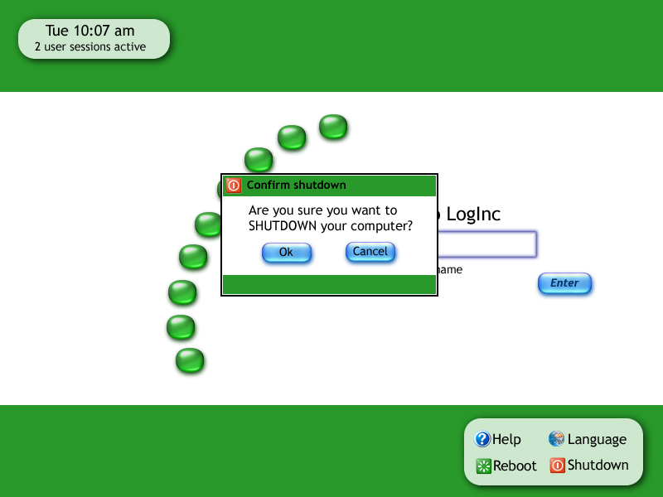
Figure B.4 Shutdown Screen
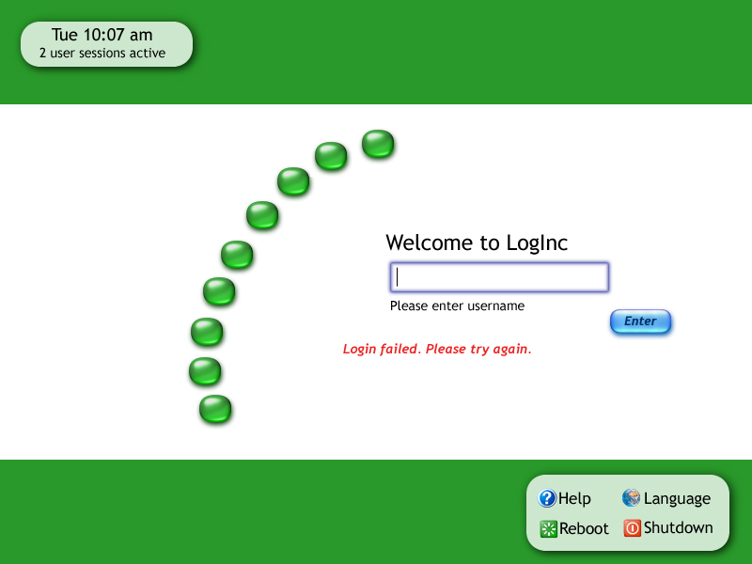
Figure B.5 Login error
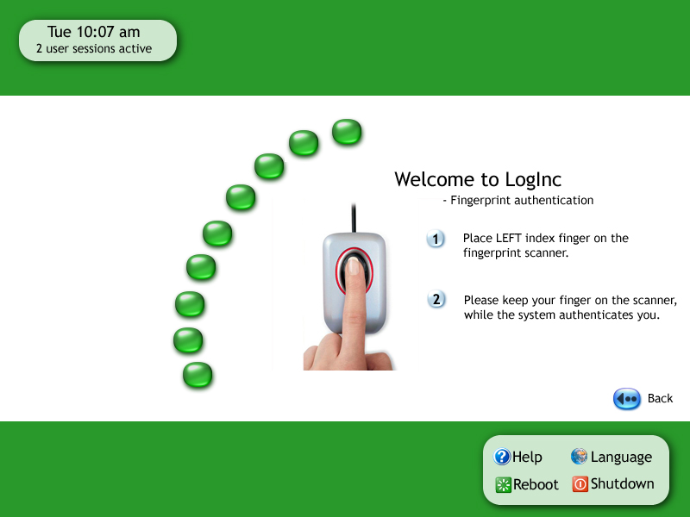
Figure B.6 Fingerprint scanning
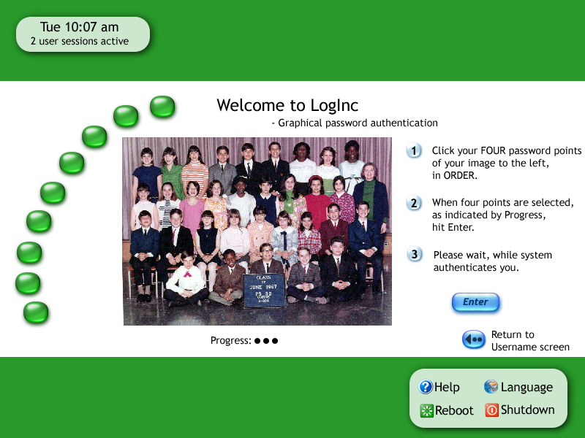

Figure B.7 Backup graphical password

